Reports for the Fenland Intergroup Meeting held at:
Old School Hall
37 Green End Rd
Sawtry
PE28 5UY
Saturday May 10th 2025, 10am – 12 Midday

Intergroup Officers
Position | Email | Name | Rotation | Reports | Attendance
Chair | chair.fenland@aamail.org | John S | 11/26 | YES
V/Chair | vice-chair.fenland@aamail.org | VACANT
Treasurer | treasurer.fenland@aamail.org | Gretchen | tbc | YES
Secretary | secretary.fenland@aamail.org | Becca | tbc | YES
Health (HLO) | health.fenland@aamail.org | Jamie B | 08/26 | YES
Public Info. (PILO) | pi.fenland@aamail.org | Richard H | tbc | YES
Prison  Probation (PPLO) | prisons.fenland@aamail.org  probation.fenland@aamail.org | John F  Morgan | tbc  08/26 | YES  YES
Telephone (TLO) | telephones.fenland@aamail.org | Gail | tbc | YES
Share | share.fenland@aamail.org | VACANT
Employment (ELO) | employment.fenland@aamail.org | Naomi M | 11/26 | YES
Electronic (ECLO) | ecomm.fenland@aamail.org |  | 11/25 | NO
Where to Find | wheretofind.fenland@aamail.org | Anne | 02/26 | YES
Armed Services (ASLO) | aservices.fenland@aamail.org | Robin | tbc | YES
Region Reps x 3 | regionrep.fenland@aamail.org | VACANT |  | YES  YES
 | regionrep.fenland@aamail.org | Jamie G | 02/27
 | regionrep.fenland@aamail.org | Naomi | O8/25
Young Persons Liaison (YPLO) | youngpersons.fenland@aamail.org | Tyra | TBC | YES
Archivist | Traditionally non-rotational | VACANT
Intergroup Officers Reports
Chair’s Report –
This last quarter I have helped put together an awareness display kit to liaise with the PI sub-committee and help organise various Armed services awareness events this summer. Went with John F. to take a tour of Peterborough Prison to help set up a prison meeting in the male wing.
Have attended various meetings in the region to meet members and GSR’s and ask either members attend Intergroup or have a group email to receive IG news and information.
John S
Fenland Intergroup Chairperson
Comments/Questions/Discussion –

Vice Chair –

Position vacant - No report
Comments/Questions/Discussion –

Secretary’s Report –
Thank you to everyone for your reports.
GSRs email addresses have been updated. Please let me know if you are not on the email list. Please also let me know if a meeting has changed time/day/venue or is no longer operating. Please note updating the Fenland website is not something that I do.
Thanks
Becca S
Secretary
Comments/Questions/Discussion –
Treasurer’s Report-
Treasurers Report for IG 2nd quarter 2025 Meeting 10/5/2025
- As agreed at the last Intergroup meeting £3,000 was sent to Region on 14th February.
- It was agreed to keep the prudent reserve at £1000.
- Another £1500 was added to the PI reserve.
- Bank charges have now been applied of £4.25+ per month at present.
Please find attached 3 months bank statements and supporting spreadsheet detailing receipts and expenditure for the group.
The balance of the account consists of . . .
£6,945.92 cash in bank as at 22/4/25 see statement
£1,000.00 prudent reserve.
£1,788.63 balance of PI reserve
£1,500.00 ring fenced for Public Information activity - yet to be proposed and actioned
£2,657.29 balance
Does the group still wish to retain a further £1,500 towards PI each quarter or should it be increased? There is an HLO project in the pipeline, costs to be confirmed but likely to be in the region of £1800 which takes out the balance of the reserve. This is in addition to what Richard/Jamie/John are working on.
Should we make further payments to region this quarter or keep back in order to increase the Public Information/others reserve?
Obviously in order to continue doing any of the above and future awareness we rely totally on the individual groups contributions to our Intergroup. Keep digging deep so we can carry on carrying the message. Thank you.
Gratitude week will soon be upon us and the 10th of June 2025 marks the 90th anniversary of the founding of our Fellowship.
The idea was to hold a separate collection in Groups on or around the week of 10th June. All Gratitude donations are recorded separately and are sent directly to head office.
Please make reference to Gratitude collection and pay separately when making the bank transfer. The same applies to cheques. Please send a separate cheque for Gratitude as opposed to Tradition 7 contributions.
From the bank charges point of view it is better to make a transfer bank to bank. Where possible could groups take this into consideration?
For groups/members wishing to make Tradition 7 contributions by bank transfer please use the details below . . .
Account Name - Fenland Intergroup
Account Number - 20787168
Sort Code - 308484
Please use your group name/area/day (where applicable) as the reference.
For groups/members wishing to make Tradition 7 contributions by cheque please send them to:
Gretchen Walker
4A Barford Road
Eynesbury
St. Neots
Cambs, PE19 2SA
When sending cheques please include details of which group this relates to and a contact telephone number or email address so that I can confirm it has been received and been deposited.
Kind regards
Gretchen
Comments/Questions/Discussion –
Public Information Report
Public Information Report, May 2025.

PI Sub Committee

The most recent meeting was on April 8th and focused on the Armed Forces Days and AA's presence at them.
Jamie G has now stepped back from organising these committee meetings, so I will be in touch to arrange further subcommittee meetings.

Health

A large chunk of the current PI budget has been ring fenced for the GP contact project. Jamie B-M will probably update us about this in his report.

Huntingdon Community Radio

Advert has been renewed for a further 2 months - it is broadcast three times a day.

Most recent interview on 'Over To You' was on March 31st.

The date for the next one to be agreed with the station. The focus will be on Young People in AA. Tyra has agreed to be one of the two participants from AA. Hopefully another younger AA member will be available to join Tyra.

PI Stand

A gazebo, table, 2 chairs, table and tablecloth, and a literature stand have all been purchased. Two more tablecloths as well.

Literature

£300 has been allocated out of the current PI budget for literature for the Armed Forces Days - 7 in June, one in August.

Armed Forces Days

There are Armed Forces Days in the following locations:

St Neots - June 14/15 - John S and Richard H attending.

Ely - June 21 - Naomi, Anthony

Peterborough - June 21 - Jamie G, David

Wisbech - June 22 - Morgan

Haverhill- June 28th - Gary

Cambridge - June 28th - Anthony, Richard H, Cate D, if available.

March - August 31st - Anthony, Robin.

There will be other people involved on all these days, and some help may be needed to make sure that everything is in place.

Printed Press

Adverts in the April editions of the Sawtry Eye and the Cambourne Crier.

Future action

I hope we can take PI into training programmes, and will hope to discuss possible options for outreach by AA at the next PI Sub Committee
Contact with professional organisations and with caring organisations is something I hope we can develop. Jamie B-M has already set up a project with GPs, and the letter to GPs which has now been completed.This is another positive step, as that letter shares positive professional backing for AA which helps us to be heard.

The PI Sub Committee will provide the space to share and develop our tactics for next steps, including any instructions we may be given by Intergroup.
Richard H
Fenland Public Information & Health Liaison Officer
Comments/Questions/Discussion –

Telephones/12 Step List -
Fenland TLO Report to Intergroup 21/04/2025
Good afternoon
This is my first report in post – first of all thank you for giving me the opportunity to do this service.
Secondly- a huge thanks to Robin, who is a great support and is sponsoring me into the role with enthusiasm and patience.
Robin is also supporting with maintaining and updating the responders manual.
There is now a NEA TLO in post – we came on board at the same time, so we have alternate weekly responsibilities for the rota – whilst individually managing our Intergroup Area.
I have come to grips with the Tamar portal.
I am on the Fenland and NEA responder WhatsApp groups – the responders are fab, very supportive of me and each other.
Robin has done all the hard work sorting out the provider, these last few weeks have run very smoothly, the only minor glitches being human error.
Figures:
 | Total calls | Engaged calls | Unanswered calls
February | 429 | 2 | 48
March | 471 | 0 | 66
April (to date) | 274 | 0 | 28

As you can see there was a higher rate of unanswered calls in March, I believe this has now been resolved.
There have been two new Responders taken on to the Rota (one from the reserves and the other a returnee) which currently leaves two vacant slots: Friday afternoon Rota A and Wednesday morning Rota B.
I am currently waiting to hear back from 2 potential new recruits.
To do:
Get to grips with meetings in the area – what’s closed, what’s on zoom etc
Recruit more responders – ongoing (GSR’s responsible in first instance, raise awareness and get names to me))
Recruit more 12 – steppers – ongoing (GSR’s responsible in first instance, raise awareness and get names to me)
(Requirement for both responders and 12-steppers is 1 years continuous sobriety, membership of a home group and the recommendation of their Secretary, Treasurer or GSR)
contact Gail at: telephones.fenland@aamail.org
Comments/Questions/Discussion –

Where To Find (WTF)
I have been keeping the WTF list as up to date as I can. As requested at the last meeting of intergroup I have added information as best I can re: open and closed meetings, wheelchair access, and which meetings offer the chit system. I will be bringing printed copies to intergroup as usual.

Best wishes

Anne
Comments/Questions/Discussions –
Prison Liaison Report (PPLO)
Current Position
There are four prisons confirmed within our Intergroup:
Littlehey
Peterborough Women’s Prison
Peterborough
Whitemoor
Highpoint North and South have been confirmed by Andrew M, the Eastern Region Prison Liaison as outside our area and looked after by another Intergroup,
Prison Reports
Littlehey
There is a regular weekly meeting on a Friday at 2.15-3.15pm.
Meetings are organised with Pheonix Futures who are operative in the Recovery Wing- A wing.
We currently have two members cleared to draw keys as keyholders and a third undergoing clearance. Key talk planned for 2nd June.
We will then have three keyholders and a rota will be put in place for the weekly meetings.
The prisoners are responsible for the meeting, there is a secretary and at a recent group conscience it was decided to use the twelve and twelve as a means to be opened up to the programme of recovery and not get stuck on drunken tales.
Participation within the prison is actively encouraged and we have seen attendance increase to around 10 regulars.
The meeting is attracting newcomers who are returning.
Pheonix Futures are also responsible for the Recovery and Wellbeing provision in Whitemoor and a meeting is planned to try to replicate the Littlehey set up and experience there.
A meeting is scheduled for Wednesday 23rd April with seven recovery and wellbeing staff members to explore what more AA can do within the prison but also in preparation for release.
Discussions have also taken place with Probation Liaison to address the concerns around licence restrictions and approved premises curfews which may prevent attendance at meetings.
Other areas allow permission where attendance at Chit meetings can be proven as a curfew exemption.
Peterborough Women’s Prison
There is currently a weekly meeting each Wednesday at 10-11am.
Local member Jackie has been doing the service each week for the past two and a half years.
Assistance Required.
Jackie would be grateful for support in making the meeting possible.
Jackie is currently the only women doing this service and if she is unable to attend then the meeting does not take place.
Peterborough (Male)
Meeting to re-start each Wednesday morning at 10.30am.
9 members have agreed to support the meeting and given their details to begin the vetting process for clearance.
The head of the recovery team is a real advocate for AA.
We have been into the prison, shown the room on the recovery wing, met a few of the prisoners and the head of recovery team (Sodexo) has accepted our invitation to come to a meeting as an observer.
Whitemoor
Contact has been made with Head of Recovery and Wellbeing, though no meaningful progress as yet.
Once again, we will require members willing to run the meeting on a weekly basis.
First step being to provide details for vetting to commence.
Other Activities
Morgan continues to facilitate a quarterly meeting of Probation and Prisons.
Issues have already been raised as to where the hand of AA can be available on prisoner release in a more structured way.
John F
Comments/Questions/Discussion –
Probation Liaison Report (PPLO)
22/02/25 GSO Probation sub-committee Workshop attended.
- 61 Attendees. – Scotland has an AA banner in some courts.
- 764 Chit meetings nationally (17% of groups)
- Glasgow Alcohol court collaborates with AA. – Police Scotland has AA information for offenders on their PDA’s. Sheriff Fleming estimates a success rate of 80%. https://justiceinnovation.org/project/glasgow-alcohol-court
- This from England and the College of Policing. www.college.police.uk/article/custody-and-alcoholics-anonymous
April; Emails sent to; Probation offices – Cambridge, Peterborough, Huntingdon, Wisbech. Magistrates courts – Peterborough, Cambridge. Police; Cambridgeshire Constabulary.
Probation & Prison sub-committee meeting 17/04/25; John (Prisons liaison), Jackie (Secretary Peterborough women’s meeting) & myself in attendance.
- Urgent help please !! Jackie needs more women to support the meeting, currently she does it on her own. It would be on a rota basis so only a commitment of one meeting a month. She will be away soon and as a result the meeting will be closed for two weeks.
- John is working hard to help bring about the new Men’s meeting in Peterborough prison.
- Both Littlehey Men’s & Peterborough Women’s meetings continue to run supporting AA’s Primary purpose.
- Jackie is purchasing literature for Peterborough prison library, to be paid by back by Intergroup.
- John & Jackie talked about the problem that people on probation are only allowed out till 7pm on license, thereby limiting their ability to attend meetings. As a result they are sadly seeing people return to prison after picking up. John & myself working together are hoping to change this, as happens in other parts of the country.
- I have been invited to attend the Littlehey meeting by John, which I am very much looking forward to.
- A goal discussed was that we would like to “bridge the gap” better between leaving prison and going onto attending meetings and staying sober. A similar issue to leaving rehab.
Comments/Questions/Discussion –
Region Representative Report (Region Rep)
Region Rep Report – May 2025
To ensure consistency of message it was agreed that the following summary compiled by the Eastern Region Secretary be used to form the basis of Region Representatives reports to their Intergroups however we did just also want to mention the following . . .
- Thank you to the groups and individuals that provided responses to the questions for conference, the time and effort you took is greatly appreciated by the Region Representatives and ensures that the conscience of the Fenland Intergroup is represented at Conference.
- These responses were presented to the Eastern Region’s Conference Delegates at the Eastern Region Pre-Conference Workshop on the 22nd of March.
- Can all Liaison Officers ensure that they are copying in the Eastern Region Liaison Officer for their discipline when submitting their Intergroup reports. Their email address will follow the same format as the email address for Fenland but Fenland will be replaced with east, for example the email address for the Fenland ECLO is ecomm.fenland@aamail.org whereas the email address for the Eastern Region ECLO is ecomm.east@aamail.org

EASTERN REGION ASSEMBLY OF ALCOHOLICS ANONYMOUS
Summary points from the February 2025 Eastern Region
Assembly
For Officer and Intergroup reports please see Assembly Minutes for February 2025.
Finances
For the 4th Quarter Report for 2024 (representing our financial year end) – quarter ending31 December 2024 - we end the quarter with a balance of £22,291.
Contributions from Intergroups for the quarter were the lowest per quarter this year at £17,900.
Yearly contributions from Intergroups were less in 2024 than 2023 - £93,302 vs £99,955 albeit we were able to pass on more to GSO compared to 2023 - £99,202 vs £84,683.
IT WAS AGREED to send £1,000 to GSO (retaining prudent reserve of £8,000 and £13,250 reserve for the Southern National Convention)
Region service positions
Big John was voted as Eastern Region Vice Chair
Kevan D was voted as Criminal Justice/ Probation Officer
Jo L was voted as Alternate Delegate
Service positions vacant: Public Information Officer, Archivist.
Board Trustee/GSO
Jim M was confirmed as the next Board Trustee for Eastern Region. To rotate into post
following the 2025 General Service Conference. The Assembly gave a vote of thanks to Jo F for her service as Trustee.
GSO finances: 1st Quarter 2024/25 GSO finances reserves approximately £112-113k below the year’s prudent reserve (W2 level), linked to increasing costs and continued reduction in contributions. The 2023 – 24 Audited Annual Report will be presented at Conference 2025.
The Quarter 1, 2024 –25 Finance Report will be sent out to Regional Treasurers in April
Literature Orders: Could Intergroups encourage meetings and individuals to consider postal costs as these are borne by the charity. Savings can be made through bulk ordering, for example through groups combing orders.

Contributions to the AAGB Big Book: Could Intergroups please highlight to fellows that contributions are being sought for the AAGB Big Book. Members are encouraged to submit their story. Deadline April 1st 2025. Details can be found on page 20 of the Winter 2024 Edition of Service News (link here AA Service News Winter 2024 - Alcoholics Anonymous )
First Response Online Workshop Saturday 7th June 10am - 12pm
Zoom login: 834 7171 4056 Password: FROSC. An opportunity to learn about our live chat and email services and find out how to get involved and help carry the message of recovery to the still suffering alcoholic. Everyone welcome! To register to attend email secretary.fro.sc@aamail.org.uk
Treasurer
Bank charges: following the meeting of the Regional Treasurers in January 2025 advice for Meetings is not to switch banks based on the criteria of bank charges. It was felt that charges would likely become the norm for all accounts. Groups should choose an account that best suits their service requirements.
Secretary
Intergroup Secretaries For those either in post, or interested in the role, of Intergroup Secretary the Regional Secretaries group is holding a seminar. An opportunity to find out more and fellowship/sponsorship for the role. Sunday May 25th 6pm to 7.30pm. Via Zoom, ID 863 9362 6785 Passcode 796753
Employment
Robert R is collating information on contacts and activities in the Region. If your Intergroup has an Employment Officer please can they contact Robert at employment.east@aamail.org
Share
The June edition of Share Magazine will be on the theme of Gratitude and are looking for articles on this theme of 90 words. Submissions can be made via this link Submit an article to Share - Alcoholics Anonymous
Eastern Region Pre-Conference Workshop
The workshop will be held at 11am on 22nd March at The Baldock Community Centre, Youth Wing, 1 Simpson Drive, Baldock SG7 6DH. All fellows are welcome to attend to find out more about the AA General Service Conference and questions for conference. Details about questions for conference can be found in the Winter Edition of AA Service News AA-Service-News-Winter-2024.pdf
Jamie
Comments/Questions/Discussion –
Health Liaison Report –
Hi again
At the time of writing this, it has been 5 months and 22 days since my quadruple heart bypass. I have been trying my best to catch up as HLO. Thanks to all of those who have carried out any Health-related work in my absence.
If anyone has done anything health related, then please can you let me know as the Intergroups HLO so I can keep a record of what’s been done.
GP leaflet campaign
Anyway, I have one major project that I am working on at the moment. This is my GP leaflet campaign.
My goal is for every single GP in the Fenland Intergroup (full time, part time, locum and trainees) to have the following on their desks:
• An introduction letter about AA, including NICE guidelines and the Cochrane review.
• The leaflet “AA as a resource for medical professionals”.
• The leaflet “Message for professionals”
• The A6 size flyer “Is alcohol costing you more than money?”
• A copy of Fenland Intergroups Where to Find.
Having undertaken extensive research using the NHS UK website and the individual GP surgeries websites, I can tell you that there are 129 GP surgeries in the Fenland Intergroup area, which has 859 GPs. All the Practice Managers of these 129 GP surgeries will receive a large envelope/parcel (according to Post Office website it may be costed as a parcel) with all the above information in it by Friday 30th May.
The letter will also contain my HLO email address for them to contact me. There will also be an invitation attached to the letters for them to attend a zoom session to give a presentation on AA. There will be a few dates to pick from. The dates for these are to be confirmed, but I am aiming July/August.
I am currently liaising with Gretchen (Treasurer) about getting money for this. I am working out costs slowly.
Further contacts
I have been back in touch with these organizations that I was in contact with prior to my heart surgery and I am awaiting a reply from all of them:
• Addenbrookes liver specialist nurse
• Cambridgeshire County Council
• Cambridge University student union
• Cambridge and Peterborough foundation trust
• CGL
• Cambridge Libraries
• Addenbrookes Chaplaincy
• Haverhill Family Practice (my own GP surgery)
• Addenbrookes Nursing training team

So there you have it. I am slowly getting back to my role. I want to create a Fenland Health sub-committee, so if anyone is interested, then please let me know as I am now beginning to appreciate that the Fenland Intergroup is a MASSIVE area.
Also, I am only able to do a few hours HLO work a week so here is to the future.
Thanks
Jamie B
Comments/Questions/Discussion –

Share Liaison Report –
No report
Comments/Questions/Discussion -
Young Persons Liaison (YPLO) –
This quarter, I have been focusing on building connections in this service position. I have reached out to a few higher education institutions in our Intergroup, and am in discussions about the potential of delivering talks about AA. I have remained in contact with some other members of our Intergroup about this, who have offered support and will deliver these talks with me when the dates are confirmed.

I have also been in conversation with the Public Information Sub-Committee of our Intergroup as well as some other fellows, following one of the Questions for Conference (Committee 6) about sharing the message of recovery on online platforms, with the intention of bringing a proposal to Intergroup in the future, conversations depending.

Finally, I am planning to attend this year's YPLO Roadshow in Birmingham on June 21st, and look forward to reporting back on this at our August Intergroup meeting.

Thank you so much for the opportunity to do service.

Yours in fellowship,

Tyra
Young Persons' Liaison Officer (YPLO)
Comments/Questions/Discussion –
Electronic Communications Liaison Officer Report (ECLO)
Electronic Communications Liaison Report – May 2025
I have gained access to both the ecmomm.fenland@aamail.org email address and the microsite manager for the Fenland Intergroup pages.
I have made the following updates to the pages . . .
- Added the latest version of Where To Find
- Added the latest version of the Intergroup Minutes
- Updated date and location of next Intergroup meeting
- Updated the Intergroup vacancy list
- Added conventions being run by Intergroups in the Eastern Region to the Local Conventions page
- Updated the Meeting Changes page with the changes that I am aware of
- Asked for updated details on the online meetings in the Intergroup and updated the Fenland Online Meetings Directory as appropriate
The Fenland Intergroup microsite can be accessed via this link https://www.alcoholics-anonymous.org.uk/intergroups/fenland-intergroup/
The Fenland Intergroup microsite can be navigated to from the main AA website homepage as shown below . . .
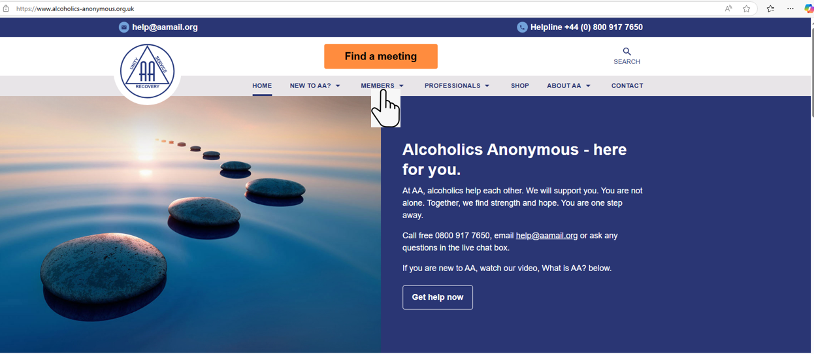

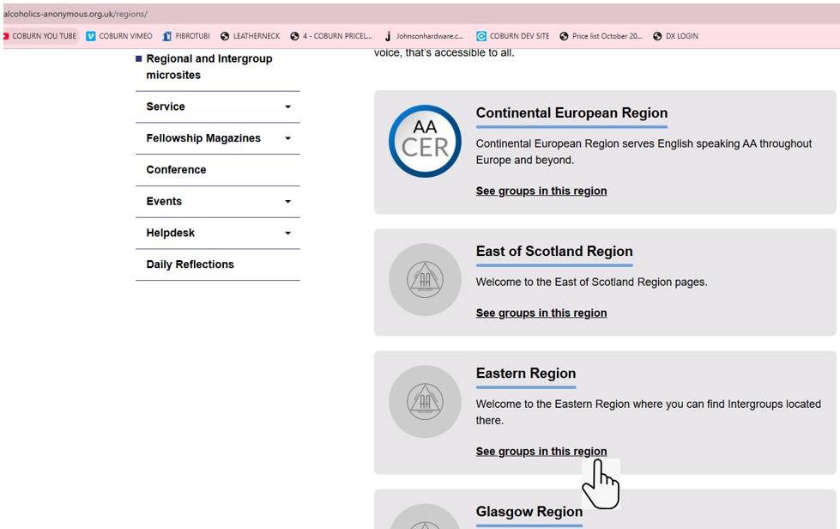
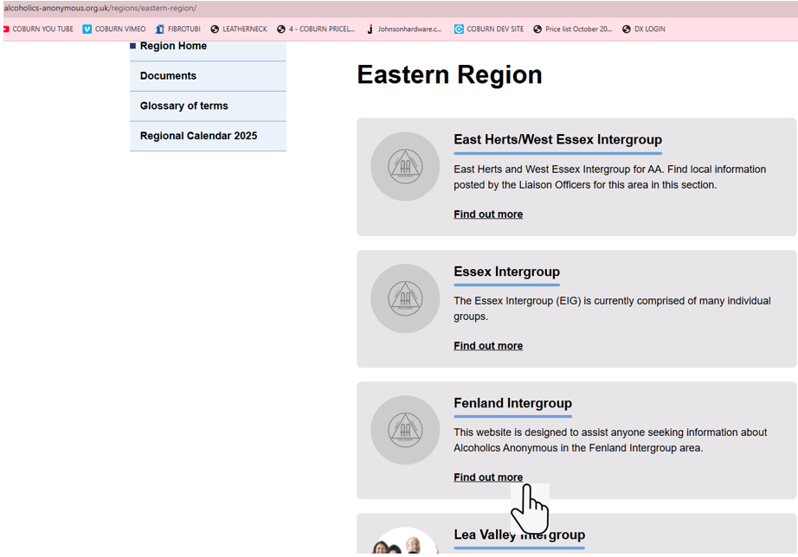
The meeting list on the landing page of the Fenland Intergroup microsite homepage is fed by the main website listings so please ensure that the details for your meeting are kept up to date using this link https://www.alcoholics-anonymous.org.uk/members/aa-meetings/pink-form-update/
If you are starting a new meeting, please use the link below to register the meeting https://www.alcoholics-anonymous.org.uk/members/aa-meetings/pink-form/
I attended a meeting chaired by the Eastern Region Electronic Communications Liaison Officer with several other Intergroup ECLO’s present, various topics were discussed including the availability of a Zoom account paid for by Eastern Region for Intergroups to use, to book the use of this Zoom account email ecomm.east@aamail.org
The possibility of linking between different Intergroups microsites to promote conventions and for changes to meetings over the festive period etc was also discussed.
If there are any permanent or temporary changes to your meetings, location, start time, duration, format etc please email ecomm.fenland@aamail.org and I will update the Meeting Changes page accordingly.
Jamie
Comments/Questions/Discussion –
Employment Liaison Report (ELO)
I have nothing much to report as I have been out of action since Christmas however I'm slowly getting back into the swing of things.

I am going to follow up on previous suggestions.

The stand at Addenbrooke’s hospital

Contact with Emmaus to do a share for staff on the workings of AA

Contact with CGL to do a share with the relapse prevention group.

Contact CGL to do a presentation for staff on the workings and benifits of aa for their clients.

Chase my local surgery up and pharmacies in Soham to display posters.

I will also be doing the armed forces stand at ELy.

Yours in fellowship
Naomi
ELO
Comments/Questions/Discussion –
Armed Services Report (ASLO) –
ASLO Report

Contact has been made with SSAFA and feedback is encouraging. Awaiting invitation to present to the Regional Hub.

ASLO is away for the period of Armed Forces weekend: the intention is for an AA presence at Ely and Cambridge. ASLO will NOT be away in 2026!

"Each day, somewhere in the world, recovery begins when one alcoholic talks with another alcoholic, sharing experience, strength, and hope.” (p xxii, Foreword to the 3rd Edition, Alcoholics Anonymous)
Robin M,
Armed Services Liaison Officer Fenland

Comments/Questions/Discussion –

Group Service Representative Reports: (GSRs)
F2F Meetings
GSR | Group | Day | Report
Aaron C | Beck Row Living Sober Thursday  Beck Row living sober meeting. Thursdays.  The Beck Row meeting continues to be well attended and we meet at St John's Church Hall.  Regular attendance is about 20 people going up to 30 with a good diversity mix of AAs with 30% of these being American servicemen or their dependents for whom the meeting was originally set up for trying to attract.  All service positions are currently filled.  The meeting is solvent and the group has sent £800 to Intergroup by time of IG meeting.  Many thanks, Aaron C | Thursday | YES
Joanne D | Brampton Friday Night  Brampton Friday night meeting is a successful, popular meeting. We get between 30 and 50 attendees per week. The kitty is healthy, currently the balance stands at aprox £500, we sent £500 to intergroup last time. The only service spot that need filling is a share finder but a plea has been put out to recruit someone to this position  Jo (GSR) | Friday | YES
Victoria D | Cambridge Unitarian Beginner’s Group 6-7pm Sunday Beginner’s Group  Sundays 6-7pm  Unitarian Church, Emmanuel St, Cambridge  Speaker meeting, with recovery chips and literature.  Attendance 15-25  Currently all service positions are filled.  Rent is up to date and we have a prudent reserve. | Sunday | YES
John M | Cambridge Addenbrookes | Monday | NO
Victoria D | Cambridge Primary Purpose Meditation Monday  Monday 7-8pm  Unitarian Church, Emmanuel St, Cambridge  Speaker meeting with recovery chips and literature. One week a month we have a topic meeting.  The group has a regular attendance of around 24.  Service positions all filled.  We are up to date with rent and have a prudent reserve. | Monday | YES
Denise | Cambridge Women’s Meeting George Pateman Court Cambridge  This is a closed meeting consisting of readings from AA literature, a monthly main share and weekly general shares.  This is a chip meeting and also a chit meeting. Attendance averages 18 women a week and regularly attracts newcomers who successfully remain sober.  The meeting is self-supporting and are able to contribute to the intergroup. |  | YES
 | Cambridge Mens | Tuesday | NO
 | Cambridge St.Lukes | Wednesday | NO
Hayley | Cambridge Milton ‘Free to talk’  The group is self-supporting. The treasurer made a donation to intergroup week commencing 7th April of £250, the group has also had a few big expenses ie rent, big literature order so our balance prior to the meeting 9th April was £16, but we are a solvent meeting, and trad 7 on week commencing 7th April will cover our rent for April. So hopefully a prudent reserve will be attained in 3 weeks taking us into the 1st week in May.  The group's meeting structure is 2 speaker meetings a month, topic meeting, AA Reading, and open floor (if 5 week month), the last 10 minutes of the meeting dedicated to ‘shy sharers’.  Living Sober and Who Me? Given to all newcomers.  All service positions filled - newcomers sponsored into appropriate service positions.  Good mix of sobriety and good message carried to newcomers, who return.  Regular homegroup members of 12 – 15, regularly 20+ in attendance.  As GSR I have agreed to obtain advice to help us to understand and implement the chit system which was agreed at our last group conscience. | Wednesday | YES
Dawn F | Cambridge Steps and Traditions step group Friday Our group is self-supporting. Engages with the chit system. Has a core group of members of 6 and most service positions are filled. | Friday | YES
Rob S | Cambridge Young People’s – Friday evening  Cambridge YP Rob (GSR) CAMBRIDGE YP FRIDAY EVENING  The meeting currently attracts a core of around 15 members each week along with a further 10-15 regularly attending members, varying slightly with the University terms. The group enjoys visitors from several areas on a regular basis due to our good geographical position and easy parking.  We are solvent and contribute anything above prudent reserve to Intergroup.  Service positions are reviewed as part of our monthly conscience meeting. Most of the roles rotate on a 6 to 12-month basis to allow members to gain the experience and pleasure of different aspects of service.  Due the advertised purpose of the Group, it attracts a good proportion of new members who are still fairly young in sobriety, but despite the name of the Group, there is no age restriction on attendance (belly button or otherwise). Several members are of the more ‘mature’ variety on either or both counts.  The Group follows the standard ESH share format, except for the last Friday in the month, when the speaker will be asked to select a passage from any AA approved literature, read it to the Group, and share on it for 10 minutes. | Friday | YES
Robin M | Cambridge Cherry Hinton Road to Recovery - Cambridge Road To Recovery, Saturday Lunchtime, Cherry Hinton - Robin M (GSR)  The Cambridge Road to Recovery group runs from 1pm to 2pm every Saturday afternoon.  The group has in the region of 20 to 30 at meetings. We have a regular flow of newcomers some of whom stay. All newcomers are given a “Who Me?” pack and those who persevere, show interest in recovery and attend regularly are given a copy of the Big Book funded by the group.  All service positions are filled. One member sits on Intergroup as Health Representative and one as ASLO.  The group is self-supporting with a prudent reserve. £300 was sent to Intergroup in Feb 25. | Saturday | YES
 | Cambridge Pateman Road As Bill Sees It | Saturday | NO
Lea N | Cambridge Lunchtime  Friday Cheddar's Lane, Cambridge meeting | Mon-Friday | NO
Tom | Cambridge Primary Purpose Meditation meeting  Service is covered.  Meeting has low but regular attendance, and we have a steady stream of newcomers and visitors.  The meeting is self-supporting Trad 7 looking after itself.  We don't do teas & coffee, but we purchase literature when we have a surplus and give literature away freely.  Last Group conscience was Feb and no changes to the format made.  Nothing else to report. | Thursday | YES
David W | Eaton Socon Monday Evening  We have nothing to report, all going well. | Monday | YES
John S | Eaton Socon Big Book – Thursday Eaton Socon Thursday Big Book Study Meeting  report March 2025  A weekly Big Book discussion and new members & visitors welcome. Provisions are made for the newcomer, and the CHIT system is now in place.  Group numbers are around twenty-five weekly. The meeting sends regular payments to Intergroup.  All service positions filled with members in service at Intergroup and region.  We are looking at achieving a bank account without fees if any groups have any recommendations.  John S.  GSR | Thursday | YES
Chris C | Eaton Socon Primary Purpose Wednesday Night Wednesday Chris C (GSR) Report – Robin  St Neots Wednesday Night – Primary Purpose Meeting GSR Report - August 2024  his is a ‘share meeting’  Meeting has a ‘hard base,’ though not necessarily Home Group, of attendees, with a  good number of members in the meeting that are in their early days and years as  well as a few who have substantial days  24  Most key positions in the Group are filled and we try to rotate within the group so  that everyone is given a chance to do service at group level. Sponsors are available  should they be asked.  Vacancies are available for a GSR, Share Finder and Greeters. However, the location  of the hall means there are always sufficient people to take on this role if required.  The group has online banking and will accept ‘pot contributions’ by transfer as well  as cash. The lack of banks in St Neots does present a problem but we have overcome  this. Statements of the Groups finances can be made available to any home group  member if requested. Our finances are totally transparent.  The group makes regular donations to Intergroup and has made a donation this  quarter.  We have a Contact Person who has been registered with GSO and the meeting  details are displayed Nationally and locally. Meeting details are also held by the  Telephone Responders in the Fenland / North East Anglian areas.  A Business Meeting/Conscious was held on 24/07/24.  In Fellowship  Robin N (Treasurer) | Wednesday | YES
Georgie | St.Neots Saturday beginners St.Marys  We have a very successful meeting and quite a few newcomers to the group.  Positions in the group are filled and the group rotates positions every 3 months. We have the chits but we have yet to start these but they are in the pipeline.  No real concerns to report. | Saturday | YES
Naomi L | Ely Discussion Report (formerly old dispensary)  Meetings are still drawing in 20+ per week with a small trickle of new members.  We continue to have a healthy reserve with bill's paid and money will be forwarded as and when accumulated.  Most service positions filled but we are struggling to find a Secretary for a 6month term. We are currently doing this position on a monthly basis.  Yours in fellowship  Naomi | Sunday | YES
Anne C | Ely Steps & Traditions – Wednesday The meeting is going well with approx 10 - 14 attending each week. All service positions are filled and we continue to make donations to the hospital. Nothing new to report. | Wednesday | YES
Michael L | Huntingdon Living Sober | Wednesday | NO
Gary B | Haverhill Recovery Monday Haverhill Suffolk Finance; Healthy  Service Positions; Fulfilled No changes in last 3months.  Attendance; 10 to 15 on average. We have a very good mix of sobriety, i.e. Years/ages/male and female. Newcomers receive a welcome pack and telephone numbers. | Monday | YES
Paul W | March Steps & Traditions | Tuesday | NO
Hayley V | Milton Free To Talk - Wednesday Evening 7 – 8pm | Wednesday | YES
Nick | Newmarket Gratitude | Sunday | NO
Carol W | Newmarket Lunch As Bill Sees It – Monday  Newmarket Monday As Bill Sees It 1-2pm  Good strong meeting. 6-10 regulars and mostly several visitors per meeting. Newcomers are doing well and meeting is solvent. | Monday | YES
Stuart | Newmarket Tuesday Newmarket Tuesday Group  Regular attendance - average 15 - 20 people. Good mix of sobriety and a good core of regulars who consider it their home group  Finances are good, rent up to date and good supply of books  All service positions are filled | Tuesday | YES
Jenny B | Newmarket As Bill Sees It | Wednesday | NO
Nick | Newmarket Big Book Study | Wednesday | NO
Carol W | Newmarket Living Sober  ﻿Good strong meeting. 6-10 regulars and mostly several visitors per meeting. Newcomers are doing well and meeting is solvent. | Thursday | YES
Tim C | Newmarket Steps & Traditions | Friday | NO
Phill H | Peterborough Daily Reflections -Monday Morning Peterborough Monday Morning Daily Reflections Meeting  This is a small meeting, although we have had an increase in numbers lately. We do the Secretary position on a monthly rotation, but we do have a GSR and a Treasurer. Tradition 7 takings tend to be low, however we are expecting an invoice for the rent shortly and after sorting this we hope to be able to send some to Intergroup. This meeting is a great way to start the week.  YiF  Phill H  GSR | Monday | YES
Dan E | Peterborough Big Book Study Sunday evenings. | Sunday | NO
Jim B | Peterborough Pyramid – Monday night  Attendance between 12-18 per week  All service positions filled  Tradition 7 healthy, have sent our first donation to intergroup recently. | Monday | YES
Benn | Peterborough Orton | Tuesday | NO
Jamie G | Peterborough St,Pauls Living Sober Thursday Night  St Pauls Living Sober Peterborough Thursday Night Intergroup Report  The format of the meeting has changed to alternating on a basis weekly between a topic discussion meeting and a Plain Language Big Book study.  Attendance at the meeting is around 8-12 per week.  The Group provided responses to the Committee 4 questions for conference.  All service positions are filled.  The group is financially stable with a prudent reserve.  The group awards sobriety chips for periods of up to one year.  We have all basic literature and can purchase any items requested by the participants.  Tea and coffee are available before the meeting starts. | Thursday | YES
 | Peterborough Aspire House | Friday | NO
Janet M | Peterborough Allcomers | Friday | NO
Stacy | Peterborough Mustardseed | Saturday | NO
 | Peterborough Meditation | Thursday? | NO
Paul | Ramsey | Saturday | NO
Emma H | St Ives Recovery – Tuesday evening  The St Ives Tuesday Evening Recovery Group continues to thrive, with at least 20 attending each week, and often more. We have a strong core membership with newcomers arriving frequently. We often have visitors from around the country who are visiting the town or working temporarily in the area. It was decided last year that the group would hold proof-of-attendance chits and these have now arrived, ready to hand to anybody who may need them.  We are solvent , fully self-supporting and recently agreed that £300 should be sent on to Intergroup. | Tuesday | YES
 | St Ives Daily Reflection | Thursday | NO
Becca S | Sawtry Twelve & Twelve the Old School House  37 Green End Rd, Sawtry PE28 5UY from 8pm-9.15pm.  The meeting is a weekly Twelve and Twelve discussion group and new members are always welcome. Group numbers are around 12 members weekly at the moment. We provide refreshments and parking is free in the car park behind the venue.  A monthly Members group conscience is held to discuss service positions and general health of the group. The meeting is fully self-supporting. All service positions are filled at present. Becca | Monday | YES
Morgan | Wisbech – Monday Wisbech Monday 6pm  The meeting is going well, regular attendance of around 10. Financially sound, and most service positions take, secretary, GSR, treasurer. We have a monthly share along with weekly "As Bill sees it" readings and short share.  It has been agreed with CGL that we can open on bank holidays where they are normally closed. | Monday | YES
 | Wisbech | Wednesday | NO
Adrian M | Whittlesey ‘As Bill Sees It’ -Thursday 7.30 to 9.00pm | Thursday | NO
ZOOM
Joan | NOW CLOSED - As Bill Sees It Thursday evening | Thursday
Richard | Big Book Study - Sunday Big Book Meeting on Zoom.  This meeting, previously a face-to-face meeting at Geprge Pateman Court in Cambridge, continues to meet on Zoom  Meeting time: 09:30 -10:30, Sunday mornings.  The meeting has some regular attenders, though we always welcome newcomers. We will soon be starting to read from the beginning of the Big Book, so now could be a good time to join us.  Group ID: 811 9433 2813  Password: 422794.  Hope to see some of you there - it is a great way to start a Sunday.. | Sunday | YES

