# Name

**Address  
Address**

**Postcode**

**Mobile**

**Email 1  
Email 2**

**Sobriety Date:**

**14th November 2022**

**Has a Sponsor.**

**Offering Sponsorship.**

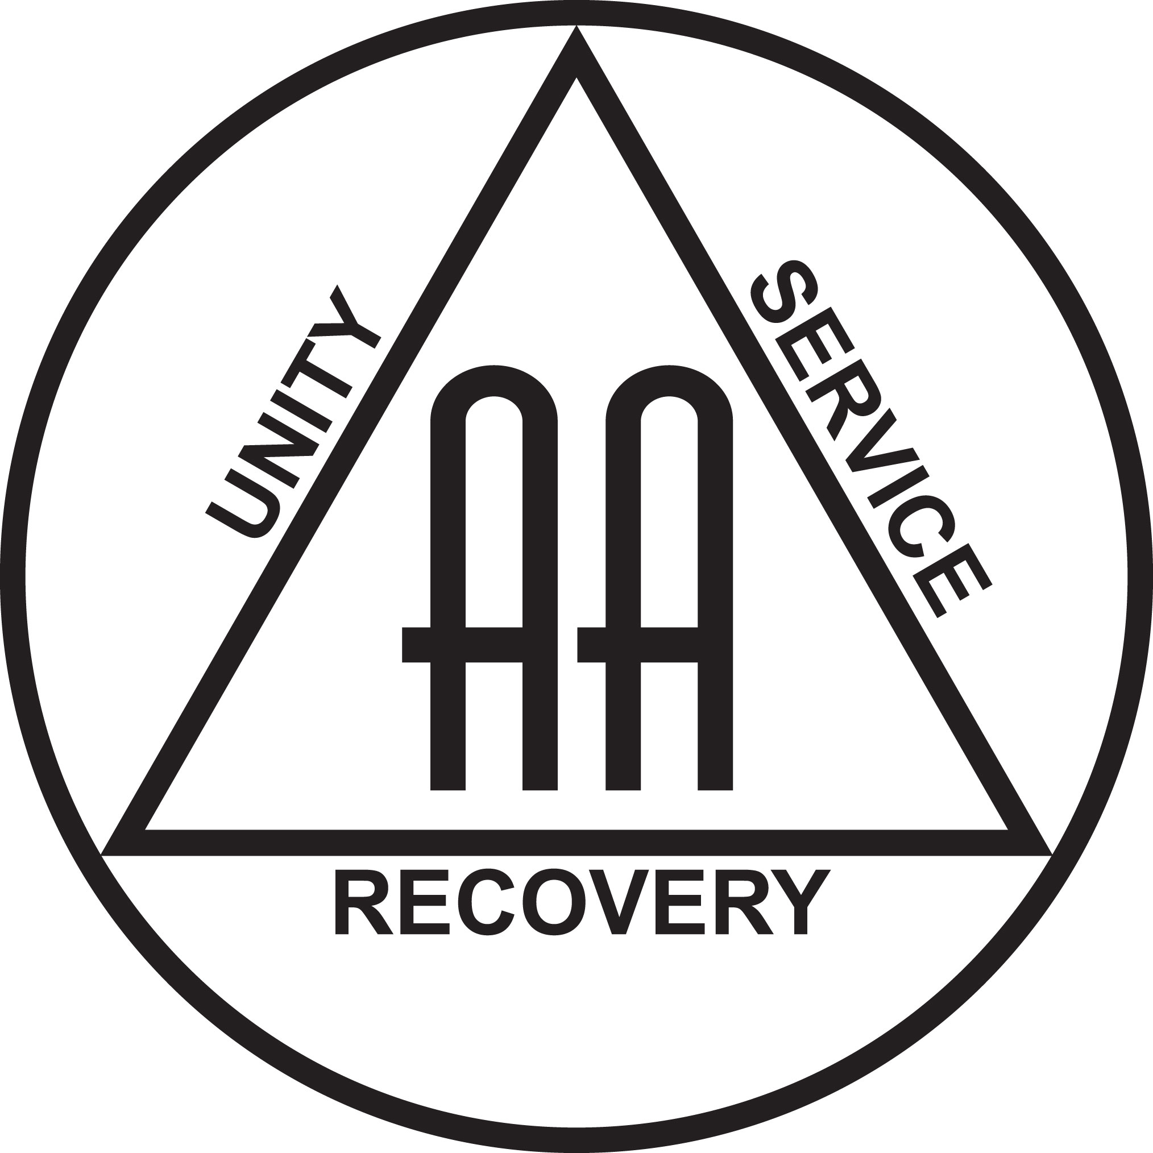

## Group Level:

Greeter & Zoom Chat Moderator – 24 Hour International Marathon Meeting - January 2023 to July 2023.

Greeter – Tuesday, Stepping Stones House 8pm, August 2023 to August 2024.

Key Holder – Tuesday, Stepping Stones House 8pm, November 2023 to November 2024.

GSR (Inc. Stand in Treasurer) – Wednesday, Holy Trinity Church 1pm, December 2023 to Present.

## Intergroup Level:

ECLO, London North Kent Intergroup – March 2024 to Present.

## Regional Level:

Attending LRS meetings in East Dulwich as a guest since September 2024.

## Other / Related Skills:

Service User Network Committee Member, CGL, Bromley – January 2023 to Present.

Volunteer Peer Mentor, Change Grow Live, Bromley – July 2024 to March 2025.

Volunteer Alcohol Recovery Worker, Change Grow Live, Bromley – April 2025 to Present.

Combatting Drugs & Alcohol Partnership, Bromley Borough, Lived Experience Partner – September 2024 to Present.

Current Enhanced DBS Check Certificate (July 2024)