My role as a volunteer within Alcoholics Anonymous is to reach out to the armed forces, public sector bodies, and charities in the services and ex-services sector.

The aim of reaching out is to ensure that anyone dealing in their professional capacity with people who may have a drinking problem is fully armed with the facts about Alcoholics Anonymous and how it can help problem drinkers.

Some general points about AA:

* AA attendance and membership can complement other programmes of recovery or assistance accessed by problem drinkers. Meetings are generally held in the evenings, and there is typically no conflict between attending day programmes etc. and attending AA.
* Access to and attendance of AA is very flexible; the problem drinker can investigate or join AA at any point in the process and is under no obligation at any point to continue if he or she does not wish to.
* AA can provide a structured recovery programme—if the individual so wishes—or can simply be a place the individual sometimes attends for additional support. AA welcomes anyone provided he or she meets the only requirement for membership, which is a desire to stop drinking.
* AA has no opinion on what other substances or addictive patterns or problems the individual has in the mix; if alcohol has been a problem and the individual seeks sobriety, he or she is welcome.
* AA does not promise to solve anyone’s drinking problem. What we do say is that, if ‘drinking is costing you more than money, we may be able to help’. This modesty aside, AA does have more than 75 years of experience helping alcoholics of every imaginable description. There is surely no standard profile of an AA member. For this reason, we encourage the net to be cast wide and to suggest to anyone with a drinking problem—whatever the apparent cause—to consider AA.
* One aim of the Armed Services Liaison discipline is to ensure that any professional helping or encountering problem drinkers and/or alcoholics in the course of his or her work is able adequately to explain what AA has to offer and facilitate the individual accessing AA.
* AA cooperates and coordinates closely with outside agencies but does not formally affiliate with other programmes.

### Contacting AA

If you need help with a drinking problem, either phone our national helpline on 0800 9177 650 or contact us by email: [help@aamail.org](mailto:help@aamail.org).

These services are staffed by volunteer members of AA who will be happy to answer your questions or put you in touch with those who can.

Or, for more general queries about AA, you can write to our General Service Office: Alcoholics Anonymous, PO Box 1, 10 Toft Green, York YO1 7NJ, tel. 01904 644026, email: [gso@alcoholics-anonymous.org.uk](mailto:gso@alcoholics-anonymous.org.uk).

Website: <http://www.alcoholics-anonymous.org.uk/>.

I’d like to set out specifically what the Armed Services Liaison discipline in AA can offer—essentially, written materials and people.

Written materials:

* Existing AA pamphlets and flyers aimed (*a*) at professionals who encounter or help alcoholics and (*b*) at problem drinkers interested in the possibility AA may be able to help them. The latter category includes general materials aimed at any problem drinkers and materials tailored for problem drinkers with current or past armed services experience. These materials are available for distribution in hard copy.
* New materials in soft copy that are more easily distributable. These can be drawn up based on existing materials and can be tailored to the needs of the organisation through which they are being distributed or based on the specific target audience.

People:

* Armed Services Liaison Officers (‘ASLOs’) able to present to professionals to explain what AA can offer and how problem drinkers can access AA.
* In areas where there are no local ASLOs in role, Public Information/Health Liaison Officers equally equipped to provide the above service.
* Volunteers coordinated by ASLOs to hold informal AA meetings in facilities or settings where problem drinkers are seeking help (either on an inpatient or an outpatient/drop-in basis) or to hold brief, informal presentations or to talk one-to-one to problem drinkers.
* 12th-steppers (experienced AA members practising the ‘12th step’ of AA’s 12-step programme, which is to attempt to carry AA’s message of recovery to alcoholics), who can introduce problem drinkers to AA and ensure they are given a firm foundation.

Access pathways:

* The AA website (see annex for a screenshot) provides instant access to details of AA meetings nationally (and English-speaking meetings in continental Europe). Anyone wishing to attend a meeting may simply look up a location and attend. Whilst this suits some people, we generally find it more effective for an individual’s first encounter with AA to be a little more structured.
* The individual can call the main telephone number (0800 9177 650) or email the main email address ([help@aamail.org](mailto:help@aamail.org)) to discuss his or her problem with another alcoholic. Based on this conversation, the individual can be provided details of local AA meetings over the phone and/or by post. For many, this provides a sufficient introduction.
* AA also offers a 12th-stepping service (see above). This can be accessed through the telephone number or email address above. Typically, this will be offered during the first contact. A ‘12th-step call’ is where a couple of experienced AA members visit or meet the problem drinker and take him or her to the first AA meeting. 12th-steppers can introduce the individual to local AA members, explain how AA works, answer questions, address reservations or fears, and often provide longer-term experience and counsel.
* AA has a 12th-stepping service specifically for the armed services. This service uses a database of experienced AA members who also have armed services experience. We have found that similar biographical experience can help to overcome apparent obstacles to joining AA. Many problem drinkers believe that some complicating aspect of their personal histories will mean AA will not work because, as they see it, they are ‘different’. A talk with someone whose experiences closely mirror their own can reduce or overcome entirely this sense of difference.
* This service can be accessed as follows: it can be requested directly from the telephone or email service by asking for a 12th-step call from someone on the ‘armed services 12th-steppers list’; it can also be requested through the local armed services liaison officer, who will have a copy of the database, too. There is a good chance that the volunteer answering the phone will offer this spontaneously, but if the caller knows the service is available, this can help where the volunteer is not aware of this relatively new service.

To sum up, I would be happy to meet you or any of your colleagues to discuss further, or to answer any questions you may have.

Yours sincerely,

[Scanned or manual signature]

[Name] [Role]

# Annex: Alcoholics Anonymous website—finding AA meetings

<http://www.alcoholics-anonymous.org.uk/>

The main page of the website shows the following:



By entering a location, e.g. ‘Whitechapel’, results are displayed as follows:

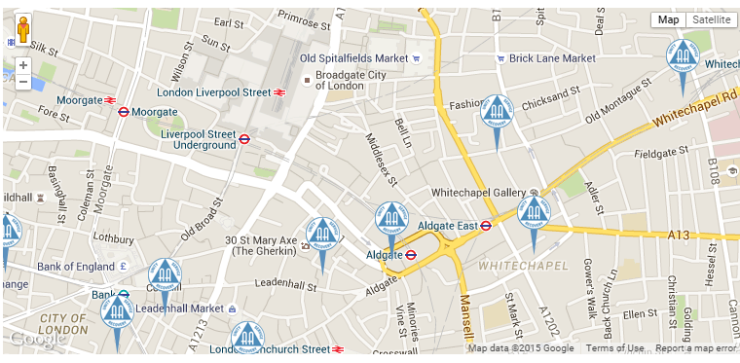

If an individual then clicks on the AA symbol, details of when and where specifically the AA group in question meets are displayed.

# Annex 2. Contacting your local armed services liaison officer

If you go to <http://www.alcoholics-anonymous.org.uk/Contact>, this will give you the numbers and email addresses of the various AA offices around the country (the numbers are not reproduced here, so that this information remains up-to-date even if the numbers change in the future). Simply call and ask for the name and number or email address of the armed services liaison officer (‘ASLO’) for the county, city, or region in question. All ASLOs are volunteers (and AA members themselves), and rotation takes place every two–three years, in a staggered fashion, so hard-copy lists of officers can rapidly become outdated. This is why we suggest this method of identifying your current local officer.