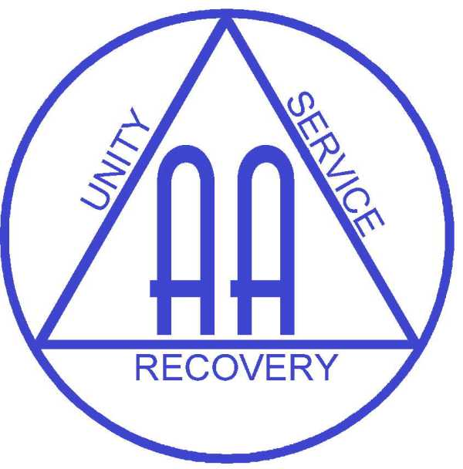
Monthly Contribution

As members of Alcoholics Anonymous, we show our gratitude through the “pot” to support our meetings and help carry the message to the still suffering alcoholic.

Many AA members wish to give an “extra” gift to the Fellowship on top of what they put into the “pot” and for some it is a replacement for Gratitude week. This can sometimes be a bit awkward. There is not usually any difficulty in finding a relatively small sum monthly, but when it comes to a larger amount annually we sometimes find it hard to put that extra bit in the pot.

Members who wish to give something extra, whether UK taxpayers or not, can make a regular monthly contribution via their bank. This money goes directly to GSO and is used to support the work of our Fellowship as a whole.

Gift Aid
If you are a UK taxpayer, and would like to increase the value of your monthly contribution you can choose to Gift Aid it. Gift Aid is a very efficient way of giving to the charity Alcoholics Anonymous as the government repays to AA all the tax paid on the gift. In this way, if you give £10 each month, the government repays a further 25% which works out at an extra £30 for the year direct to AA helping to carry the message further.

The terms of this donation are strictly confidential and the details you supply for tax purposes remain at the General Service Office. However if the HM Revenue & Customs should demand those details we are obliged to disclose your name and address.

What do I have to do?

- Complete the Standing Order Mandate and send it to your bank.
- Complete the Membership Confirmation / Gift Aid form and return to the General Service Office.

STANDING ORDER MANDATE

To. ________________________________ (your bank’s name)

Address _____________________________________________

_____________________________________________

Please pay to;

HSBC Plc
13 Parliament Street
York
YO1 8XS

For the account of The General Service Board

Sort code 40-47-31 Account number 63930408

The sum of £ ______________ words _________________________pounds

One the __________ day of ___________________ 20 ____ and monthly

Thereafter until countermanded by me and charge the account of.

_____________________________ Account number _________________
(Your account name)

Signed ______________________________

Date _____________________

Membership Confirmation / Gift Aid Form

The General Service Board of Alcoholics Anonymous (Great Britain) Limited
PO Box 1, 10 Toft Green, York YO1 7NJ
Charity number 226745

Seventh Tradition – signature required

In order for us to be able to accept your generosity and comply with our seventh tradition, please confirm your membership of the fellowship by signing below. This is strictly confidential and for General Service Office use only.

Signature ………………………………………………………..

Gift Aid – only complete this section if you are a UK taxpayer and wish your monthly donation to be Gift Aided.

If you would like to apply Gift Aid to your contribution, please fill in your details below. The details given on this form are strictly confidential and are kept at GSO but if demanded they must be submitted to HM Revenue & Customs.

Using Gift Aid means that for every pound you give, AA gets the extra 25 pence back from the Inland Revenue, helping your donation go further. In effect the Inland Revenue refunds to AA the tax you have paid on your donation.

An example is that a donation of £10 can be turned into £12.50 just so long as donations are made through Gift Aid. Imagine what a difference that could make, and it doesn’t cost you a thing.

First Name______________________ Surname_______________________

Address _________________________________________________________

__________________________________ Postcode______________________

I want all donations in the future to be Gift Aid until I notify you otherwise.

